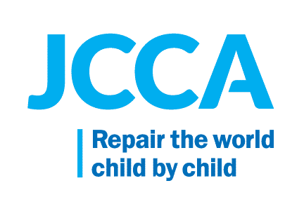
Policy

JCCA is committed to ensuring the safe transport of ill youth to the Pleasantville Health Center (PCS) Health Center for proper treatment.

Procedure

Campus youth that are ill will be brought to the PCS Health Center for treatment. It is recommended that the campus youth be escorted to the PCS Health Center by a campus staff person, i.e. medical driver, cottage staff or safety staff. The campus staff person needs to call ahead to the PCS Health Center to alert the Health Center medical personnel that an ill youth is being brought to the Health Center for treatment.

The ill campus youth is to be brought to the rear entrance of the PCS Health Center ONLY so as to limit contact with other youth and personnel. The campus youth will be greeted by PCS Health Center medical personnel and brought to the dedicated examination room. Medical personnel will be wearing surgical masks, gloves and will be practicing universal precautions when greeting and then examining the ill campus youth.

If the ill campus youth needs to be transported to the PCS Health Center by vehicle the campus medical team will be alerted that the ill campus youth has to be transported by vehicle. When possible the medical team will deploy a campus medical driver and vehicle to collect the ill campus youth and transport the youth to the PCS Health Center’s rear entrance. The campus medical driver will be outfitted with Personal Protective Equipment (PPE) when necessary. The campus medical driver will ensure that the ill campus youth is the sole passenger in the vehicle and will be seated in the back seat.

Campus youth that become ill during off campus visits will be picked up and transported back to campus by campus medical drivers. If necessary the campus medical drivers will be outfitted with the Personal Protective Equipment. The campus medical driver will seat the ill campus youth in the back seat while the transport the youth back to campus. As stated above the campus medical driver will call the PCS Health Center to alert them to the youth’s arrival at the Health Center and will deliver the youth to the rear entrance of the Health Center as per protocol.

The surfaces of the examination room will be disinfected after every ill patient. Please note that ill campus youth with respiratory symptoms will be outfitted with a surgical mask when deemed necessary. Ill campus youth will not be permitted into other areas of the Health Center so as to protect other youth and personnel.

Campus medical personnel are committed to ensuring safe medical practices and therefore will keep their distance from each other in Health Centers. Medical personnel will stagger schedules so as to ensure proper coverage but also limit exposure. Medical personnel that treated the ill campus youth will not come into the general work space at all during the that day. S/he should also take breaks separately from the others

All healthcare workers should be in scrubs that are removed and laundered daily as soon as possible upon return home.

