How to connect your tablet or laptop using a VPN

Modified on: Sat, 14 Mar, 2020 at 4:54 PM

Overview:
The following instructions help you connect your tablet or laptop device to JCCA's network while working away from the office. This service will allow you access to all the resources of the network just as if you were sitting at your desk. This includes your H: Drive and shared departmental drives. You should expect that browsing folders and opening files on servers on the network will be a little slower when using wireless internet. Best results are experienced with a strong WiFi connection or when wired directly to your home's internet router with a network cable. When WiFi is not available, you are able to connect using a cellular hotspot, but speeds will be much slower and you may be disconnected and reconnected multiple times. A cellular hotspot is not recommended for long connection periods. It should only be used sparingly in situations where WiFi is not available.

Date Posted: 03/13/2020
Applies to: Windows 8.1, 10

Instructions:

Windows 10 only

1. Start at the Windows login screen before entering your username and password. Click anywhere on the screen to display icons on lower right.

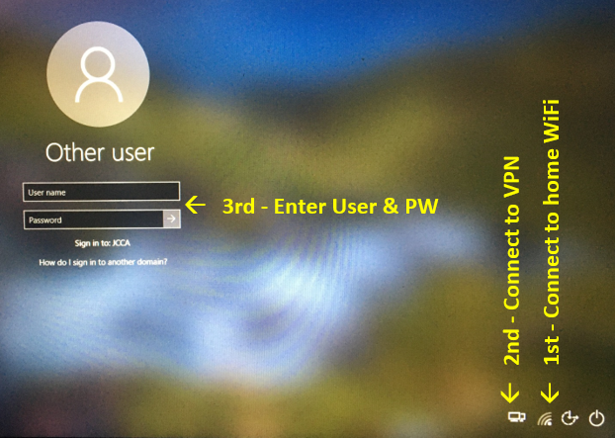

2. Once you login to Windows you are ready to work just as if you are at the office.

Windows 8.1 only

1. Connect your device to an available WiFi network or personal cellular hotspot.
(NOTE: You should only connect to known WiFi networks that are password protected. Do not connect your tablet or laptop to Public WiFi networks)

2. Open the Cisco AnyConnect VPN client by clicking on this icon on the Windows taskbar.

If you do not see it there, you can also click on the Start button and type Cisco in the Search field.
3. Before pressing connect, make sure the field is not blank. If it is, type ‘key.jccany.org’ as shown in the image below.

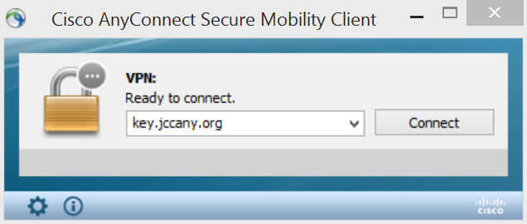

4. Press connect. A new window appears prompting you to enter your JCCA Windows credentials. These are the same credentials you used to login to your computer.
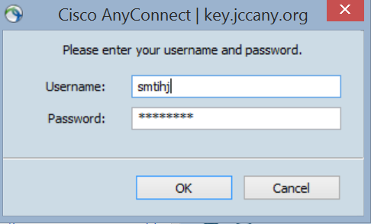

5. Press OK and you will then be connected to the JCCA network. Validate your connection by clicking on the icon from step 2 and you will see the following window:

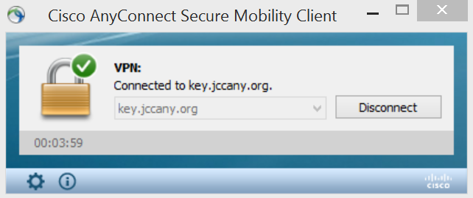

In addition, the WiFi symbol (looks like signal waves) on the lower right corner of the screen will change to a small monitor with a network cable next to it, just like when you are docked at the office.

6. It may take up to two minutes for the VPN connection to be completely established. Expect to see messages on the lower right corner of the screen that say Reconnecting... and then Connected... In some instances, when you have low WiFi signal, this may occur more than once and intermittently throughout your session.

7. You are now connected to the JCCA network. You should navigate to Windows Explorer to connect to your shared network drives. They may have a red X next to them and this is normal. Click on each of them to connect and you should be able to browse, open, modify, and save files.

